* DLL is a shared library that contains code and data that is used by more than one program at a time and like the executable file DLL cannot run directly.
* DLL (Dynamic-link library) is called by the application.

**Steps to create DLL in C++**

Here I will describe how to create a DLL project in C++ using the visual studio.

* Open the visual studio and click on the menu bar to create a new project. See the below Image.

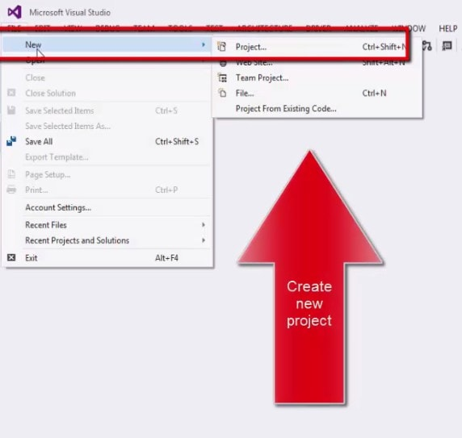

* After selecting the new project, a new dialog box will be open, here select the project type Win32 and give the name to the DLL project.

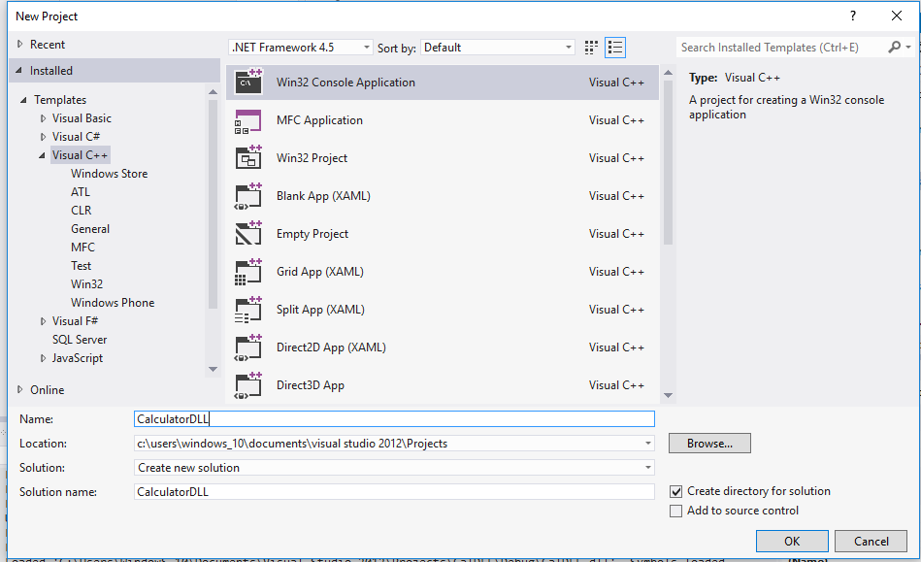

* On the Overview page of the Win32 Application Wizard dialog box, choose the Next button. After clicking the next button a new window will open. It is Application setting window here we will select the type of the application and click on the finish button to create the DLL project.

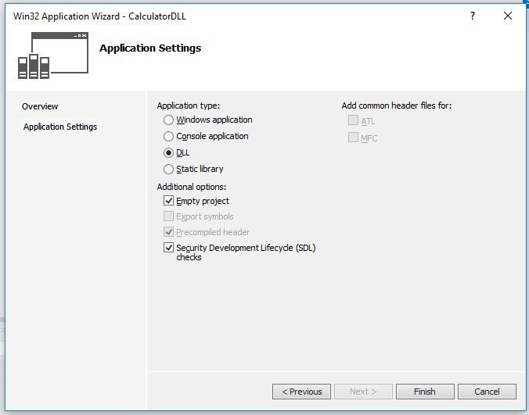

* After creating the DLL project you have to add the header files and source file as per your requirements. Here I am adding only one header file.

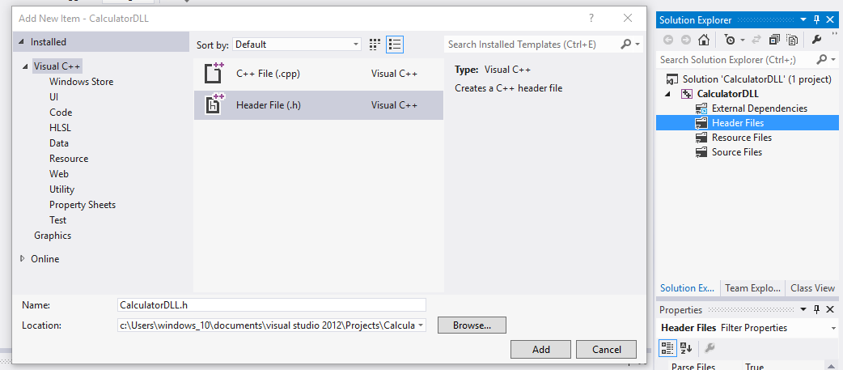

* When you have created the header file then write the desired content as per the requirements. Here I am creating a library that performs some basic arithmetic operation like addition.

#ifndef _CALCULATORDLL_h_

#define _CALCULATORDLL_h_

#ifdef CALCULATORDLL_EXPORTS

#define CALCULATORDLL_API __declspec(dllexport)

#else

#define CALCULATORDLL_API __declspec(dllimport)

#endif

CALCULATORDLL_API int Addition(int x,int y);

#endif

**Note:** When you have created a DLL project then automatically PROJECTNAME_EXPORTS is defined in preprocessor symbols of the DLL project. In this example, CALCULATIONDLL_EXPORTS is defined when your CALCULATIONDLL DLL project is built.

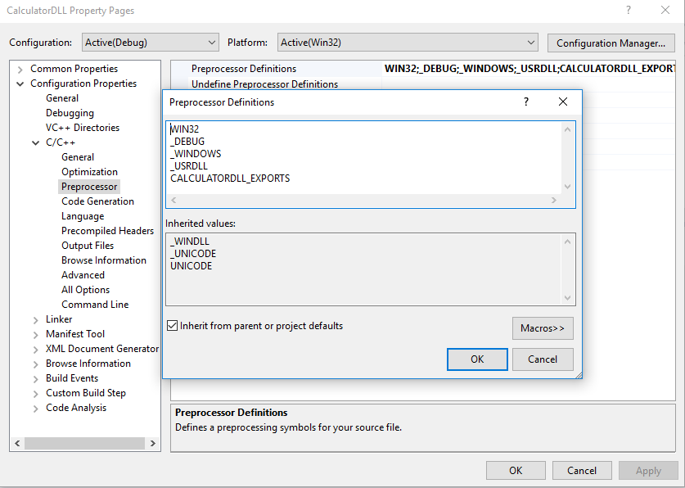

* Now it’s time to define your class member function in the source file. Here I am defining all member functions in CalculatorDLL.C file.

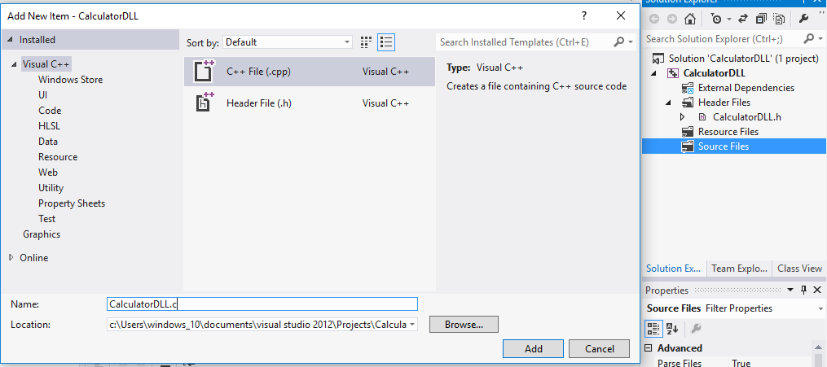

#ifndef _CALCULATORDLL_c_

#define _CALCULATORDLL_c_

#include "CalculatorDLL.h"

int Addition(int x,int y)

{

int z;

z=x+y;

return z;

}

#endif

Now source and header files are added to the DLL project, to create the DLL and lib just build the DLL project. If everything is fine and your DLL project compiles perfectly without any error then a DLL and .lib file will be generated.

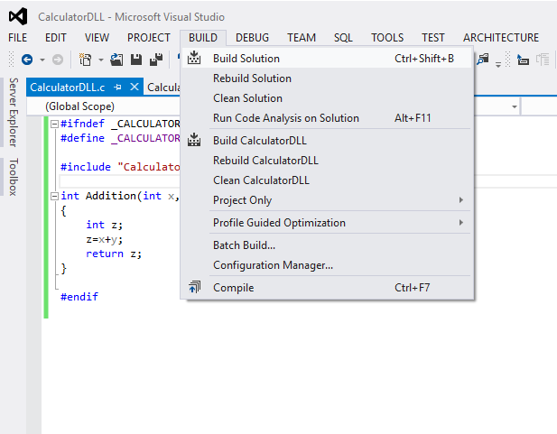  
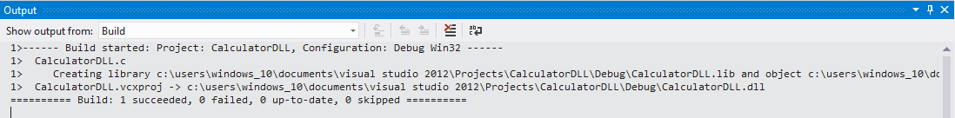

**Steps to create a C ++ Application**

Here I am creating a c++ application that will use the created DLL.

* Click on the menu bar to create a new c++ Application project that uses the DLL which I have created just now.



* After selecting the new project a new dialog box will be open, here select the project type Win32 Console Application and give the name to the App project.

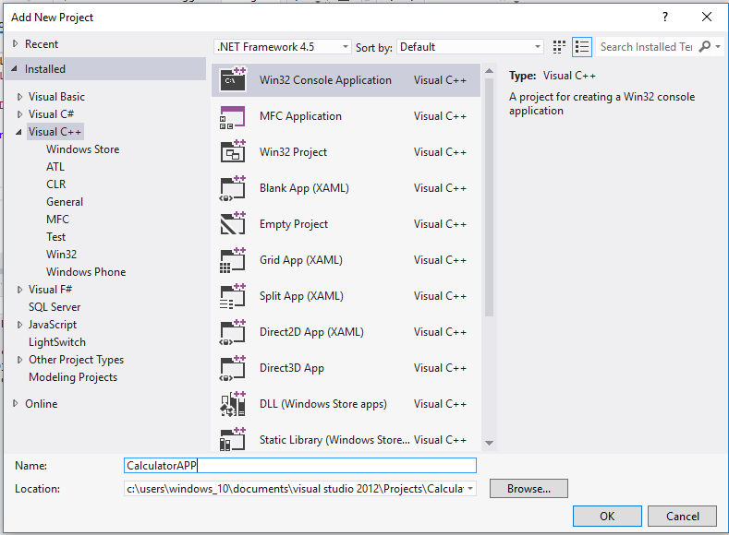

* On the Overview page of the Win32 Application Wizard dialog box, choose the Next button. After clicking the next button a new window will open. It is the Application setting window here we will select the type of the application and click on the finish button to create the c++ Console Application project.

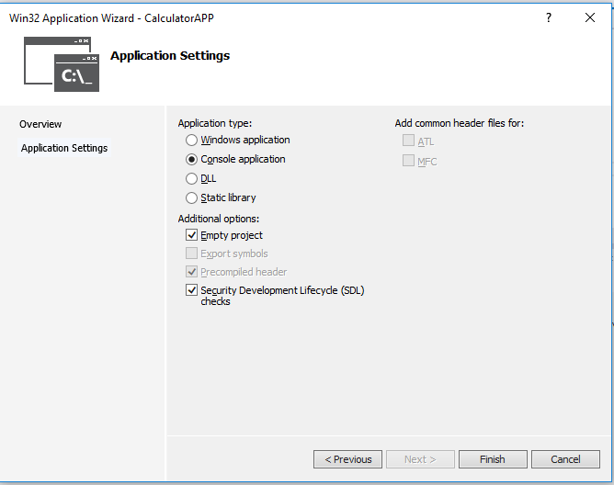

Now your C++ application project is ready to use the DLL ( Dynamic linking library).

**How to Link DLL with c++ Application**

Here I am discussing simple steps to link the DLL project with the C++ Application project.

* When we have created the DLL and Application then after that we have to reference the DLL to the Application that makes the enable to Application to use the DLL function as per the requirement. To do this, under the CalculatorAPP project in Solution Explorer, select the References item. On the menu bar, choose Project, Add Reference.

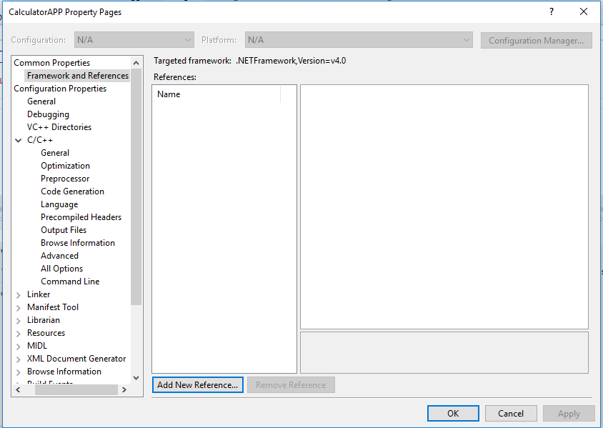

* When you click on the Add new Reference then a dialog box will be open which has the lists of the library that you can reference. You need to just click on the check button to the required library. Here only one library is showing in the dialog box.

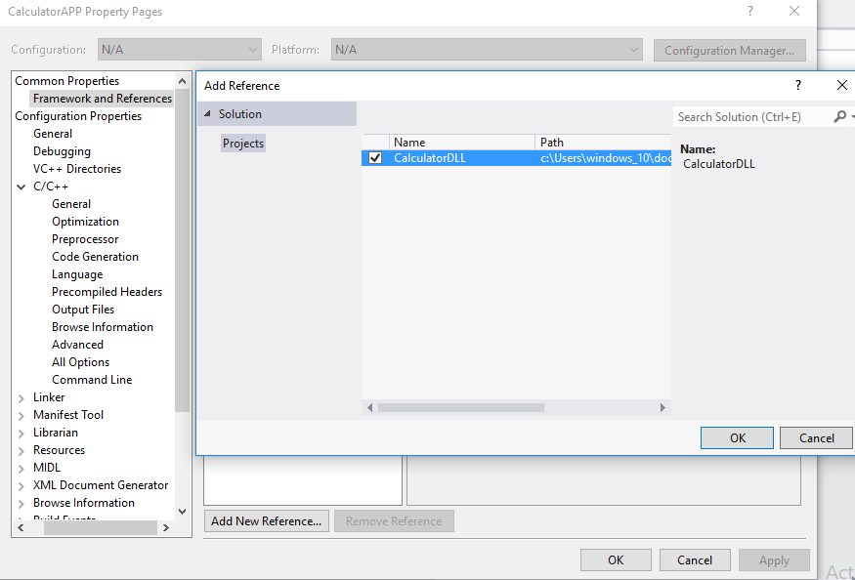

* Now your created library is linked with the created Application, but before using the DLL in Application you have to add the DLL header file. We just reference the DLL header file to give the path of original DLL header files in Application project included directories path.

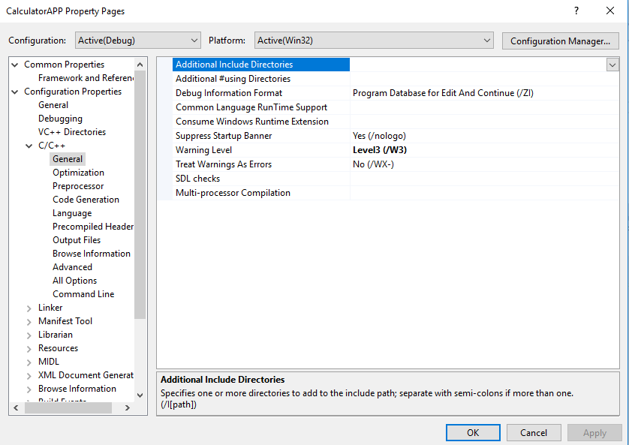

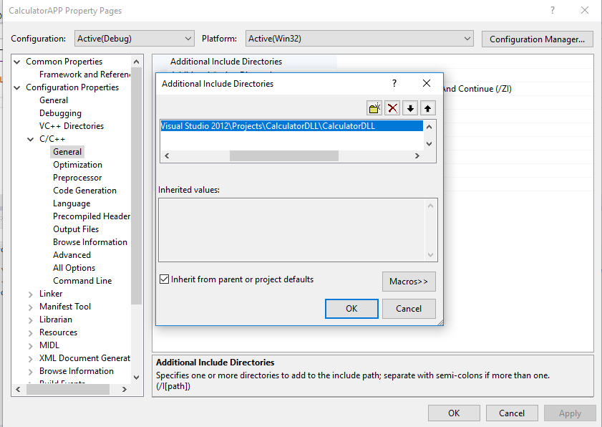

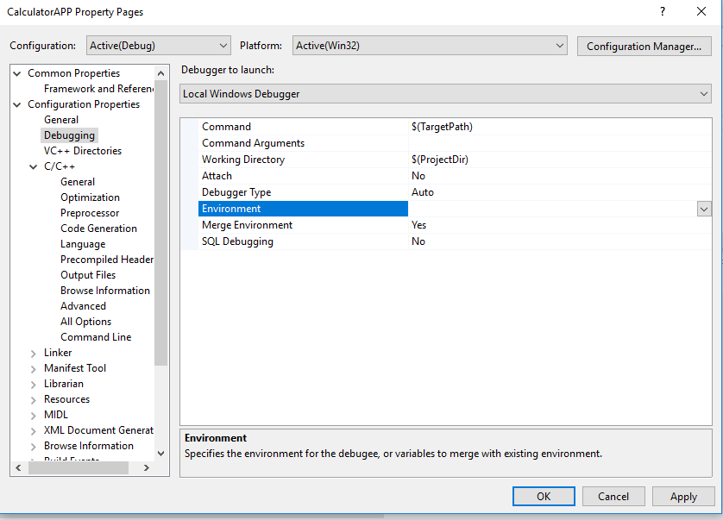

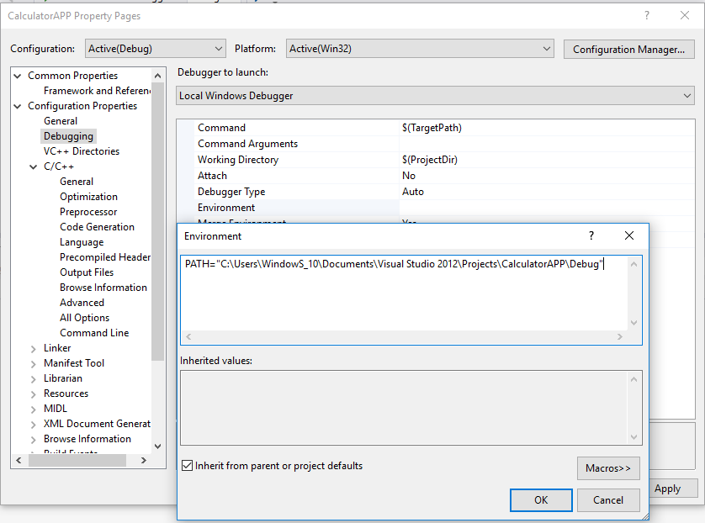

* Now it’s time to define your class member function in the source file. Here I am calling all member functions in CalculatorAPP.C file.

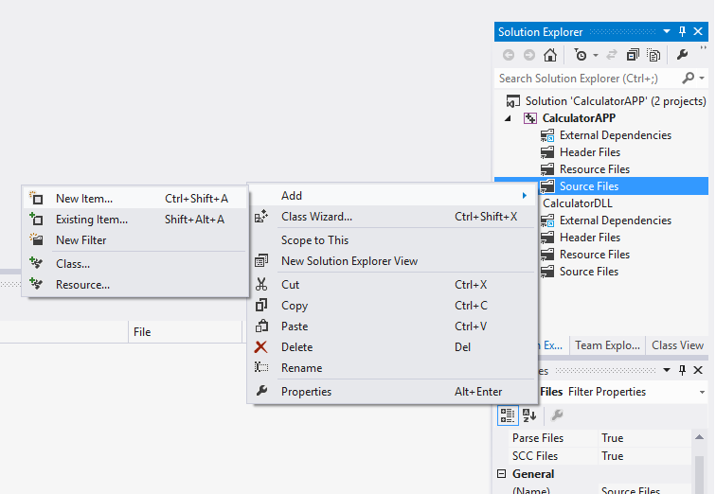

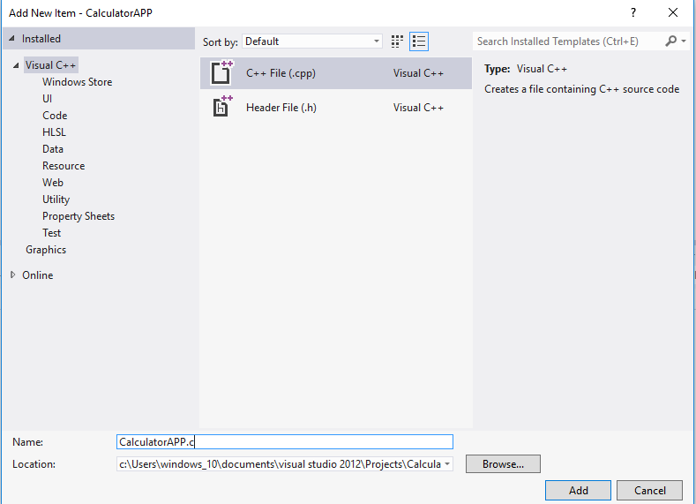

#include<stdio.h>

#include "CalculatorDLL\CalculatorDLL.h"

int main()

{

int a;

a = Addition(10,5);

printf("Addition=%d\n",a);

return 0;

}

